SCORE Registration Portal – overview

Login page for Score

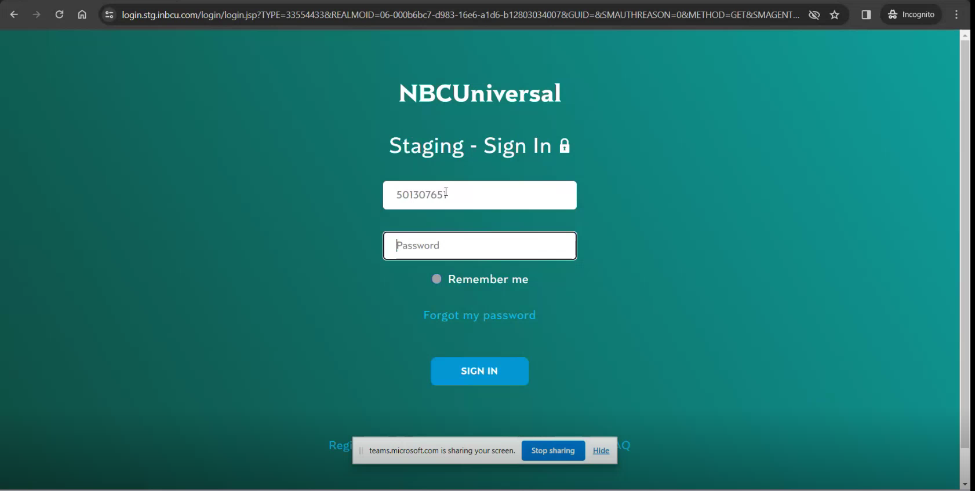

Score landing page – named as “pick a door”  
Here in this page, registration can be done for remote ( for US citizens ) and Olympics ( for all others )

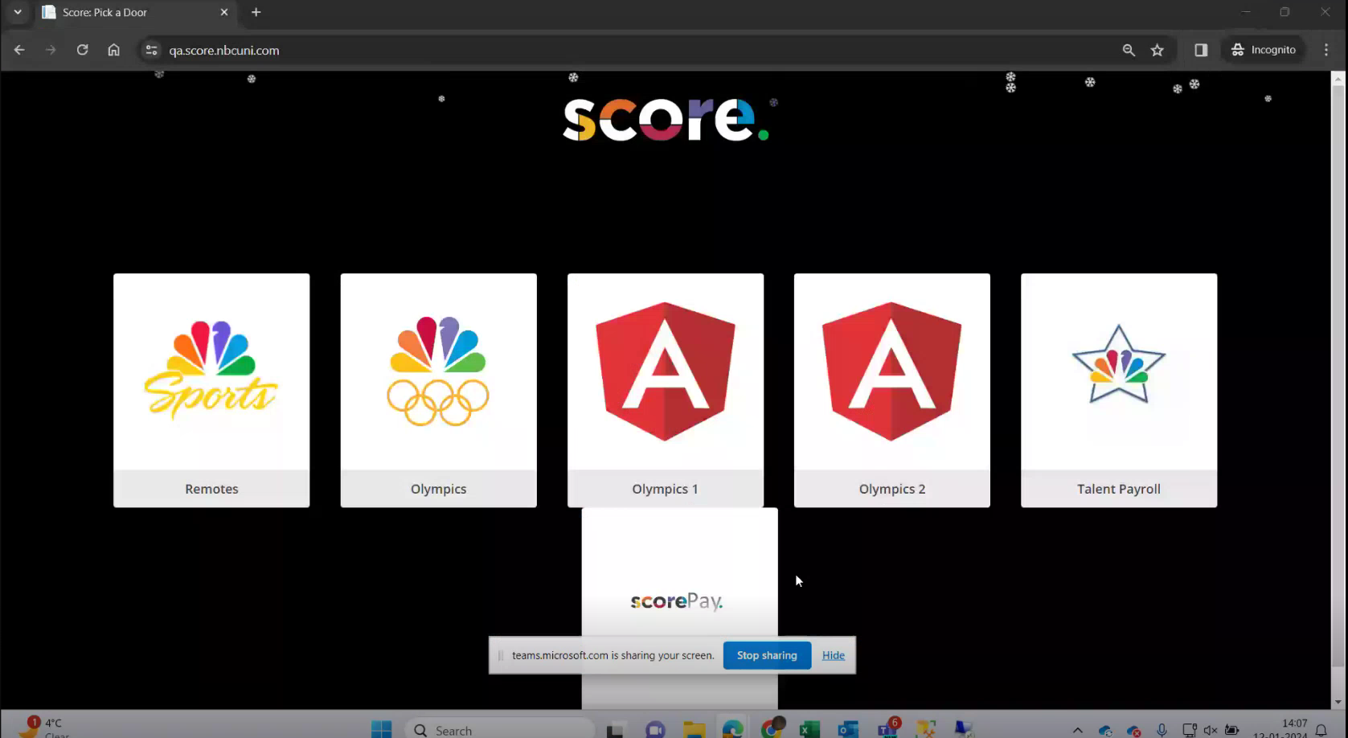

After entering on remotes or Olympics we have to create an event. An event can be any Olympic game like basketball or archery. There are options to create an event in the left navigation bar.

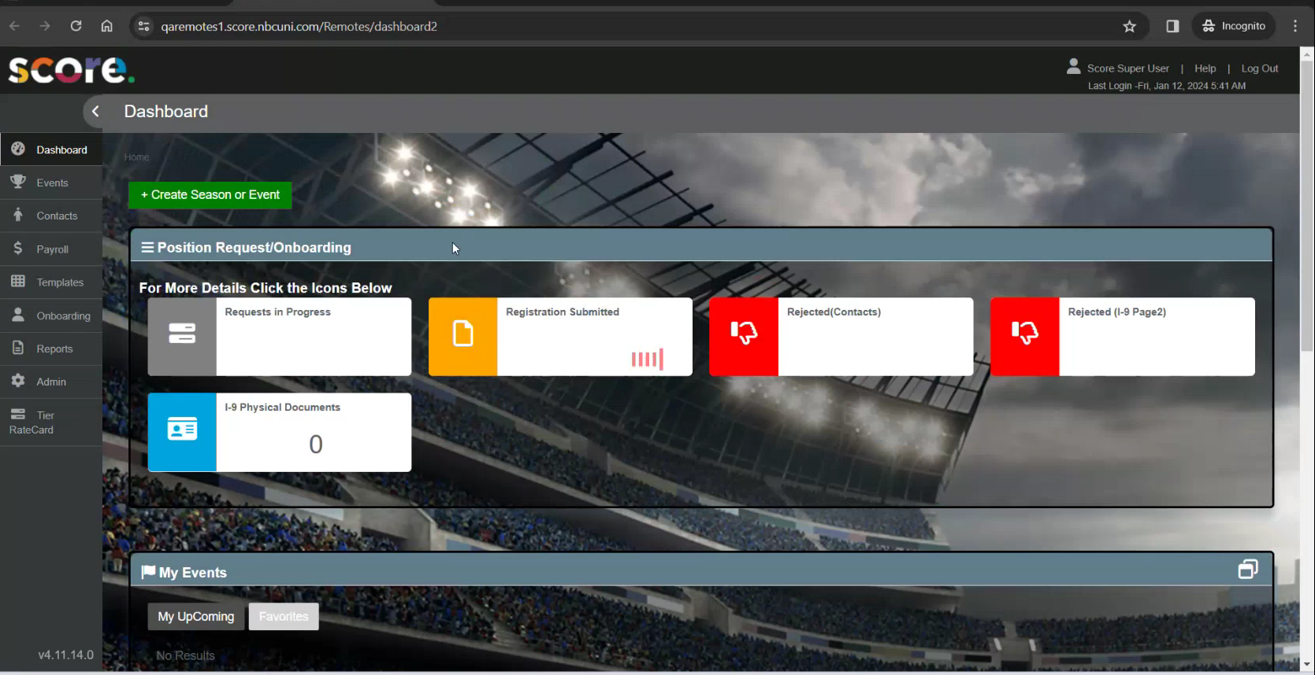

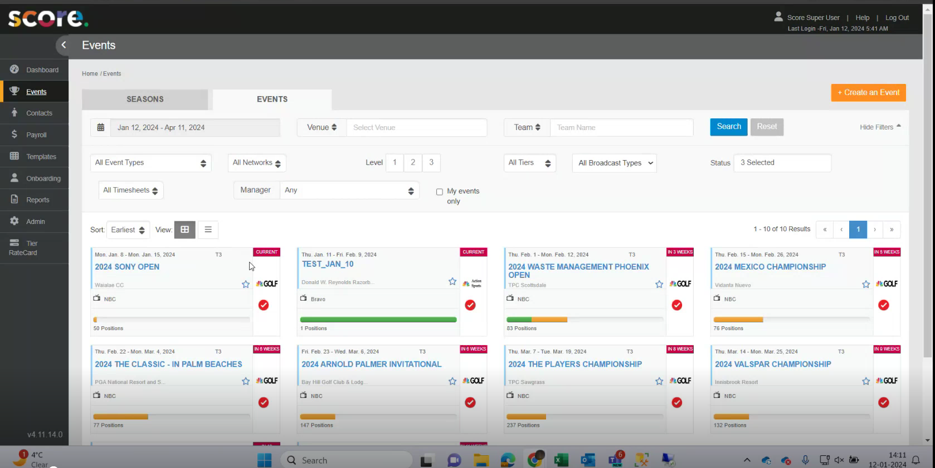

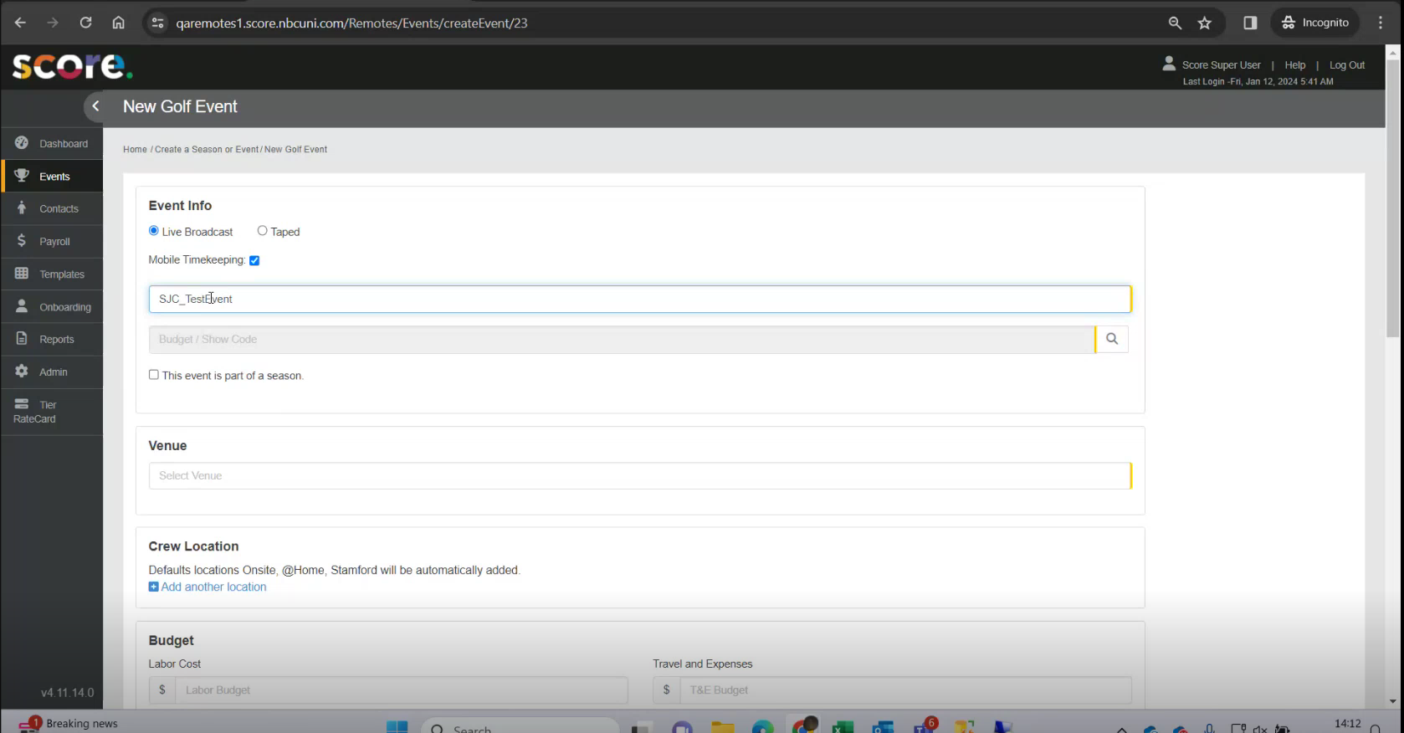  
  
On creation of an event, an unique Id is generated, called as event id.

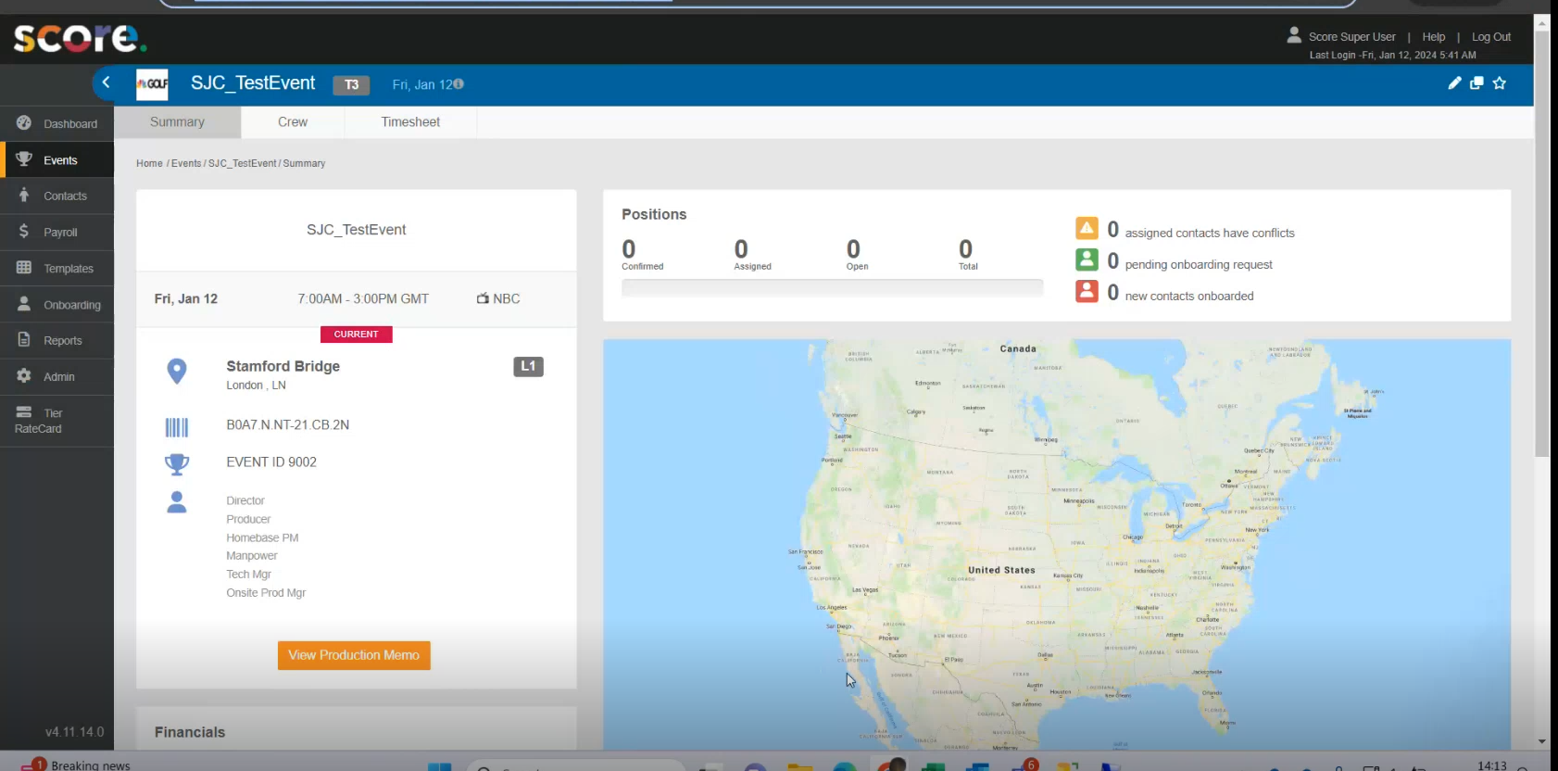

After creation of event, in the CREW tab, we have to create or enter positions for that event like cameraman, directors, producers etc.

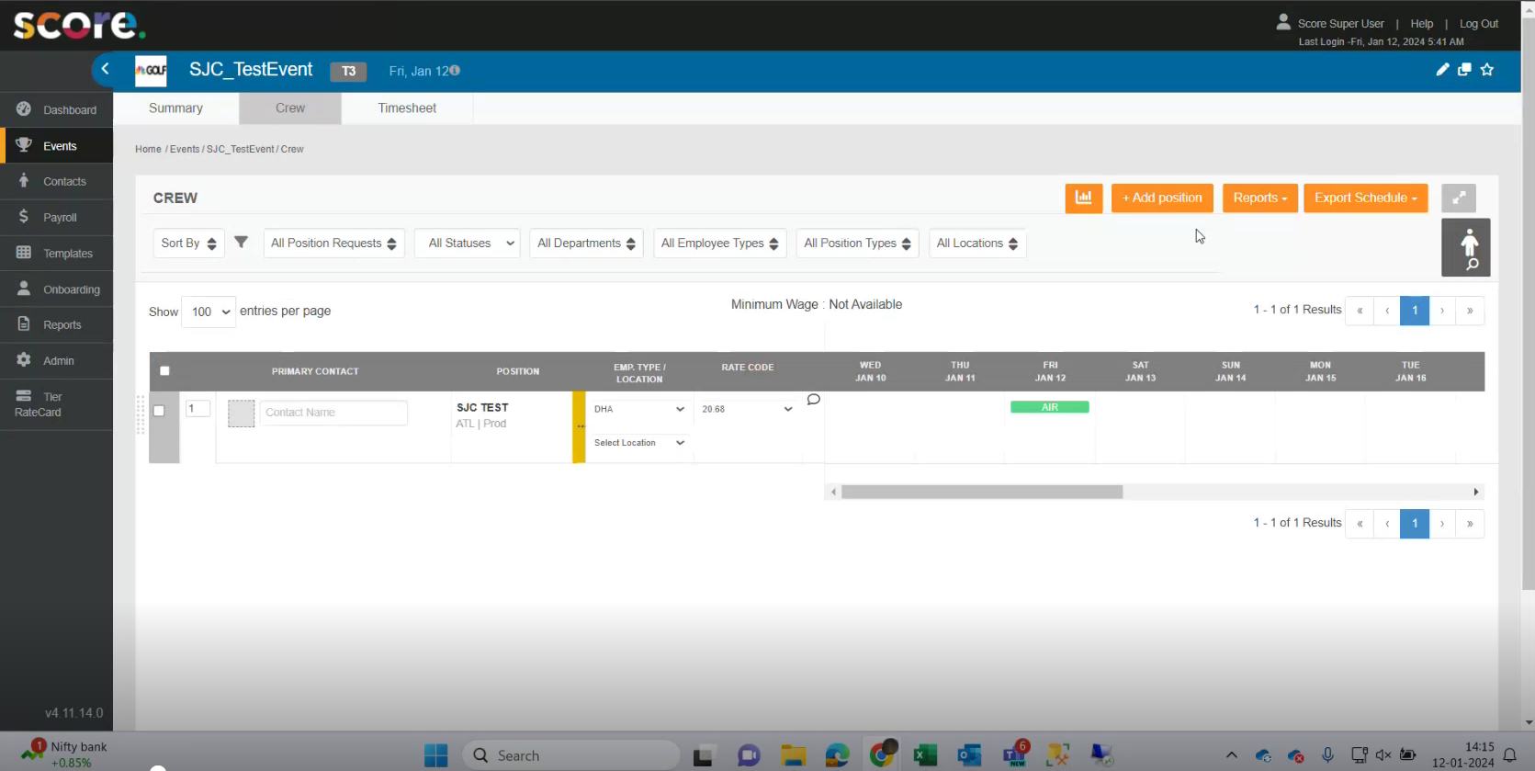

And for these positions, some contact persons are assigned. Now these contact persons will do the registration for the event.  
  
While creating contact, we have to choose vendor or non-vendors.

Vendors are those who are working for NBC, like Capgemini people.

And non-vendors are NBC employees.

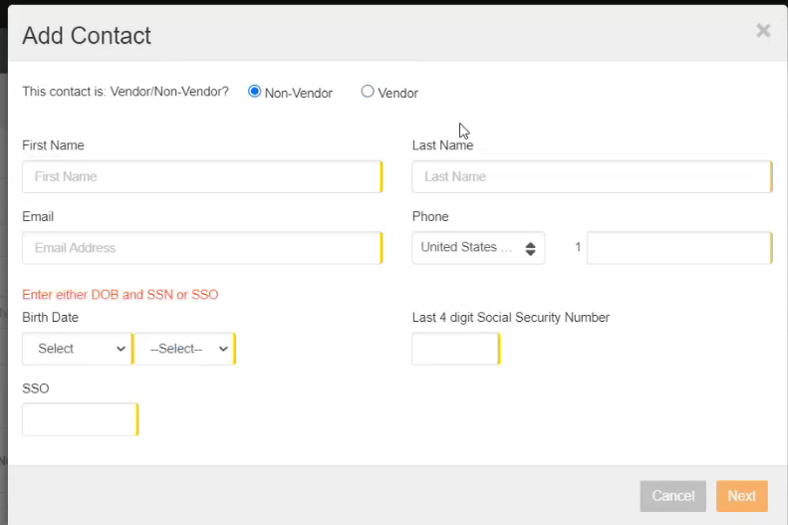

After creation of a new contact, it needs to be registered. So for remotes, a registration request has to be sent in the registration portal but for Olympics directly a contact person is registered and an welcome mail is sent to their email id. For each new contact an unique contact id ( also called score id ) is generated.

Any person who is already a part of the company and registers as a contact, the registration system sends an email to them and asks to get registered with the SSO id they have and a temporary password.

But any new member who is not a part of the company gets assigned as a contact, they are sent a temporary username and a password to get registered.

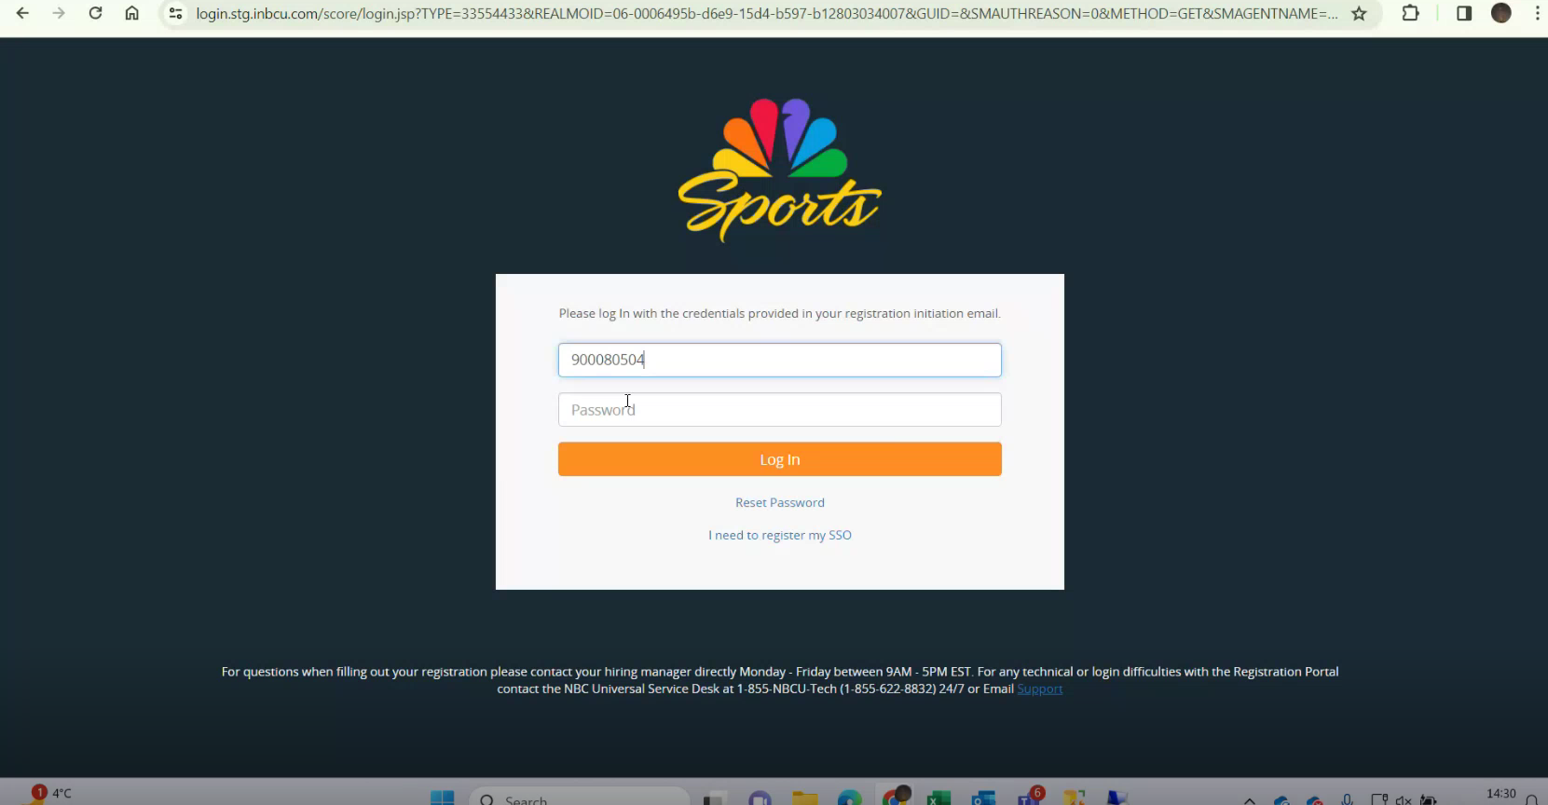  
  
So, after registration the contact person have to change their password.

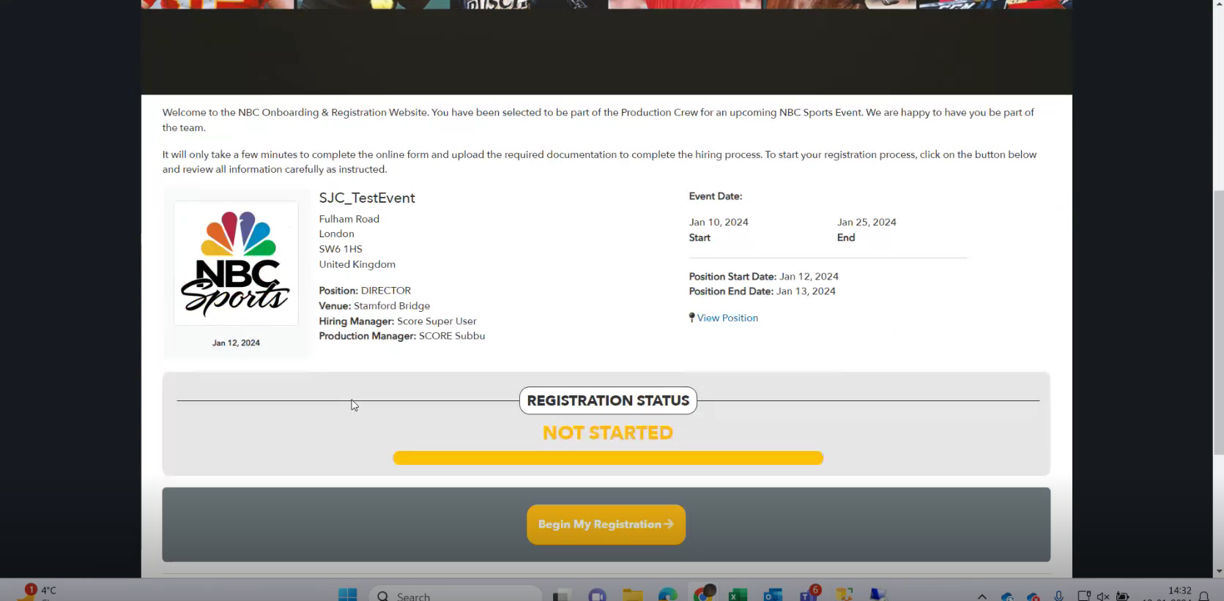

This is the registration page looks like.

Contact person have to share personal info, emergency contact and some related documents for registration.  
  
These are the list of documents that are needed.

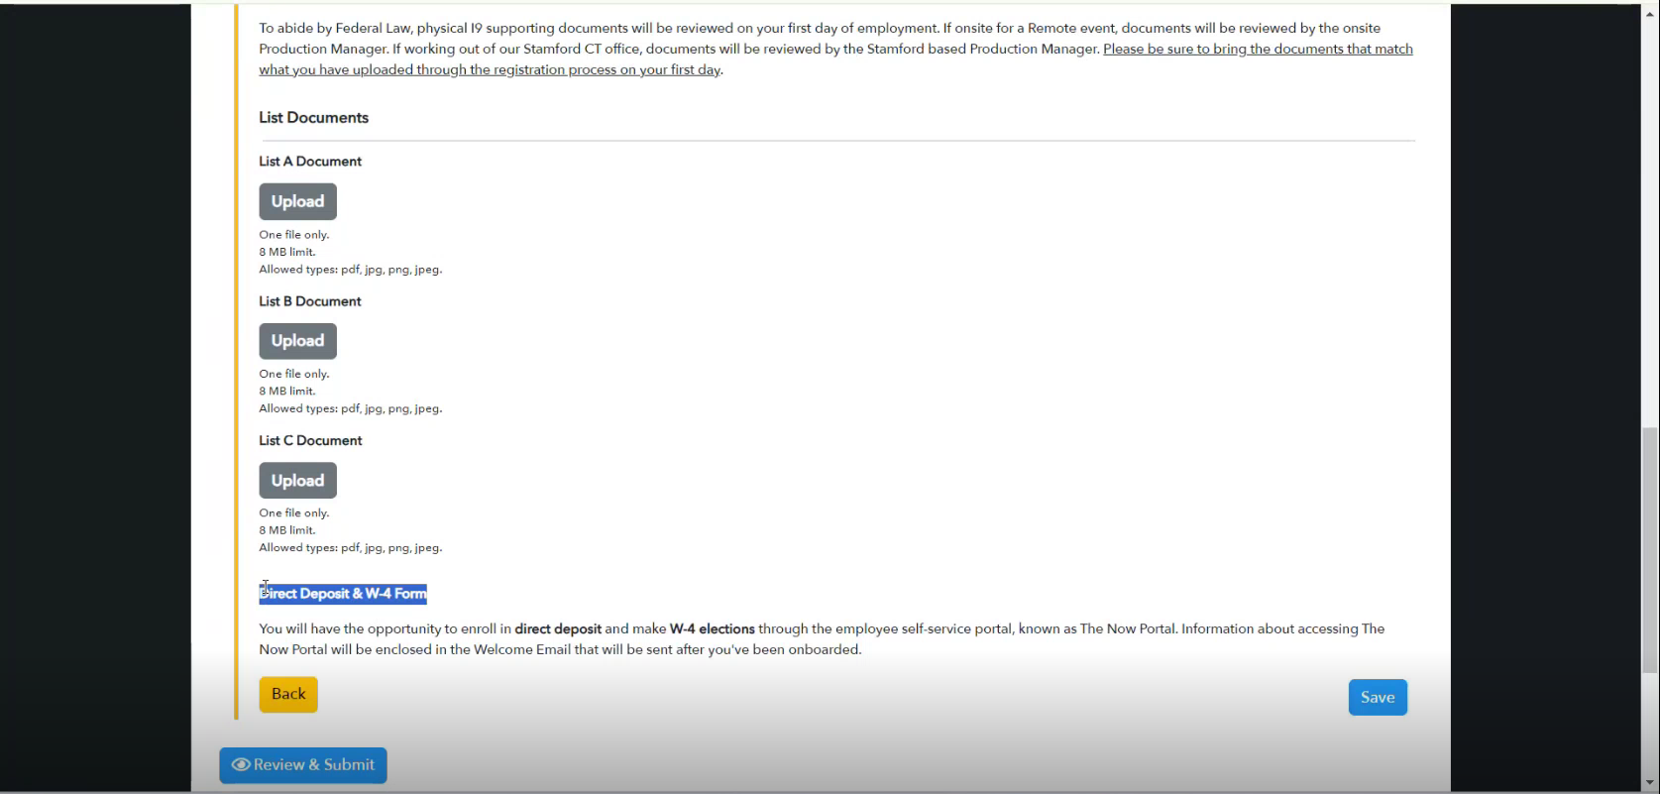  
  
After registration

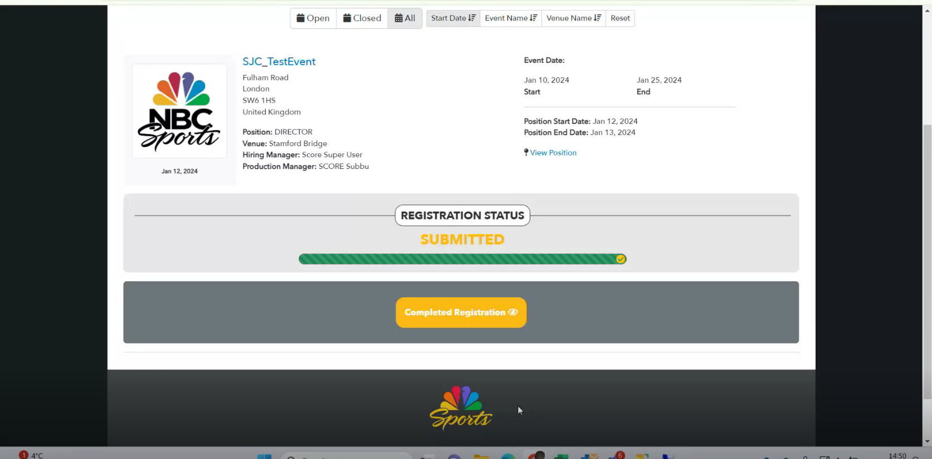

The supervisor has to verify all the documents ( i9 doc ) that are used by contact persons. So they need to login to the score portal.

This is onboarding page.

This is contact page whose HR is not verified.

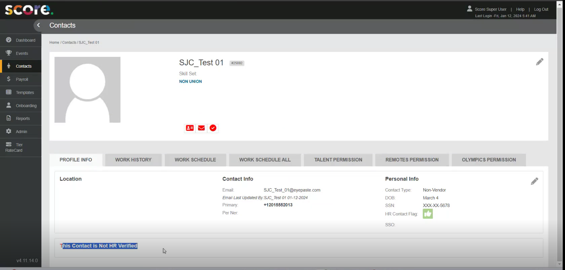

If HR verified, only then contact person can fill their time cards. And this is only for the remote sites. There is no such restrictions on the Olympics.  
On Olympics, vendors and non-vendors can fill the time sheets.   
But for remotes sites only the non-vendors who have an active SSO can fill the time sheets.

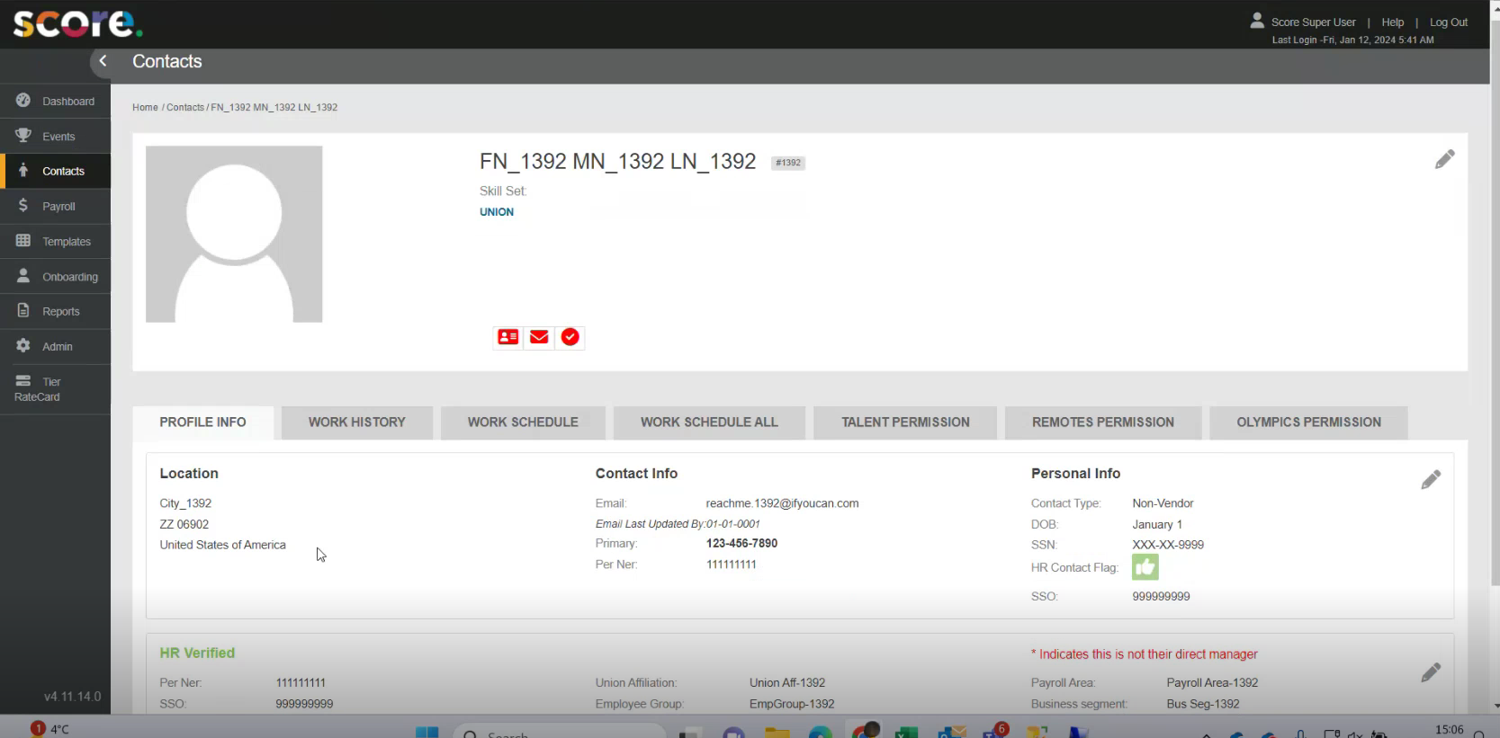  
This is the crew tab.

